Comprehensive Operating Systems & Linux Lab Assignment
Instructions: Perform all the experiments and answer all the theoretical questions listed below. For practical tasks, insert a screenshot of your terminal (showing both the command and output) below the respective question.

Part 1: Basic Linux Command Line Interface
Q1. Navigating the Linux Filesystem
Use commands like pwd, cd, mkdir, rmdir to create and remove nested folders.
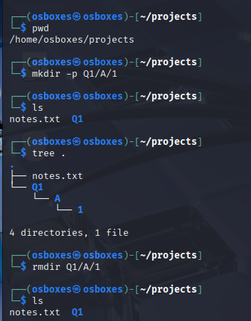
Q2. File Operations
Create a file using touch, add content with echo, and view it with cat, tac, head, tail.
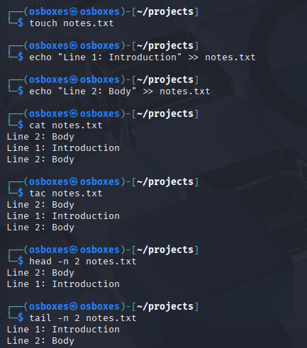
Q3. File Compression and Archiving
Compress a file with gzip, extract it, and create/extract a tar archive.
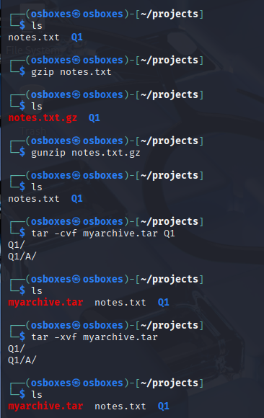
Q4. File Linking and Deletion
Create a hard link using ln, then delete the original file and verify the link.
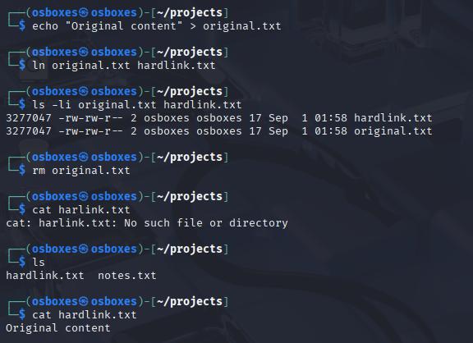
Q5. System Info and Utilities
Use cal, date, banner, and bc for system information and calculations.
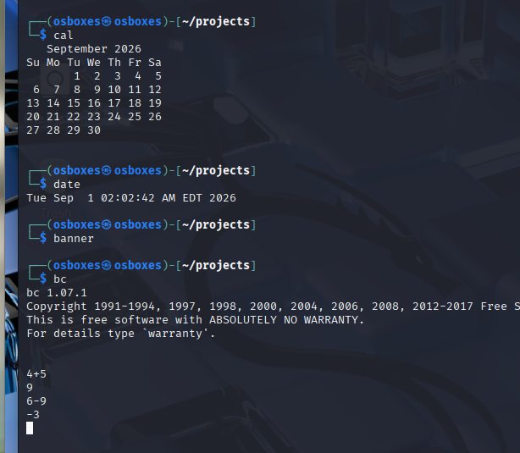
Q6. User and Process Information
Identify current user, logged-in users, user activity, running processes, and background jobs (whoami, who, w, ps, jobs).
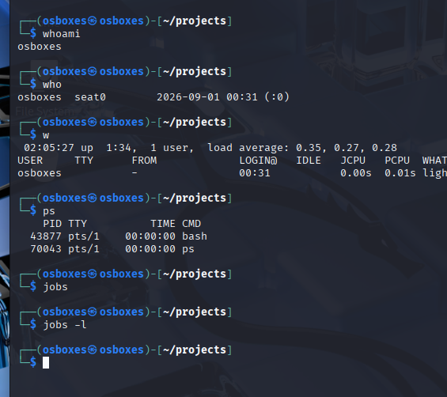
Q7. Searching and Comparing Files
Search files using find/locate, examine file types, and compare two files with diff.
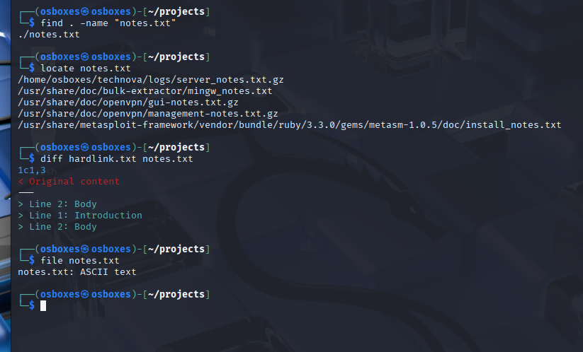
Q8. Viewing Documentation
Use man and whatis to explore manual pages for commands like ls or grep.
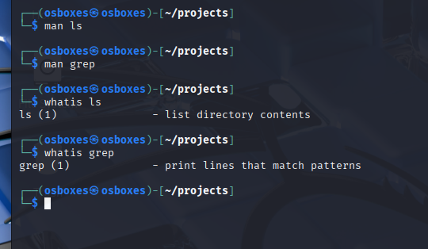
Q9. File Counting and Sorting
Create a sample file, sort it, count words/lines using wc, and search keywords using grep.
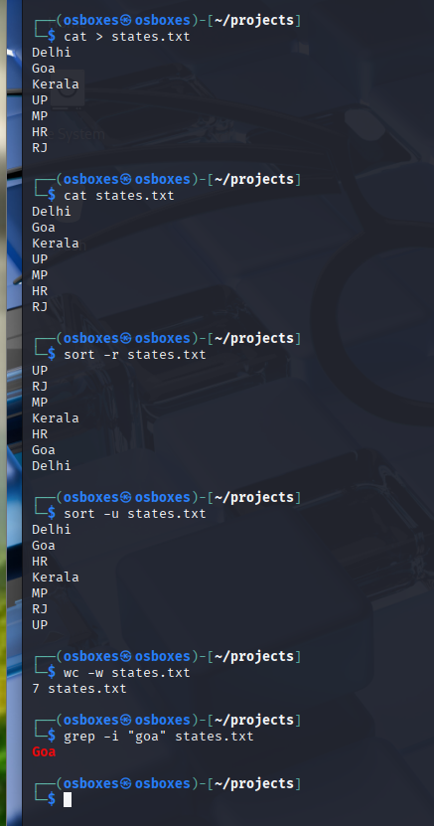
Q10. File Copy, Move, and Print
Copy a file, rename it using mv, list directory contents, and simulate printing with lpr.
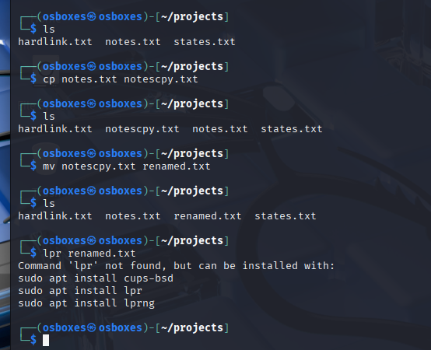

Part 2: Advanced Linux Command Line Interface
Q11. Advanced File and Directory Management
Use advanced options for nested directories (mkdir -p), recursive listing (ls -lR), recursive copy (cp -rv), and finding/deleting files based on type and name.
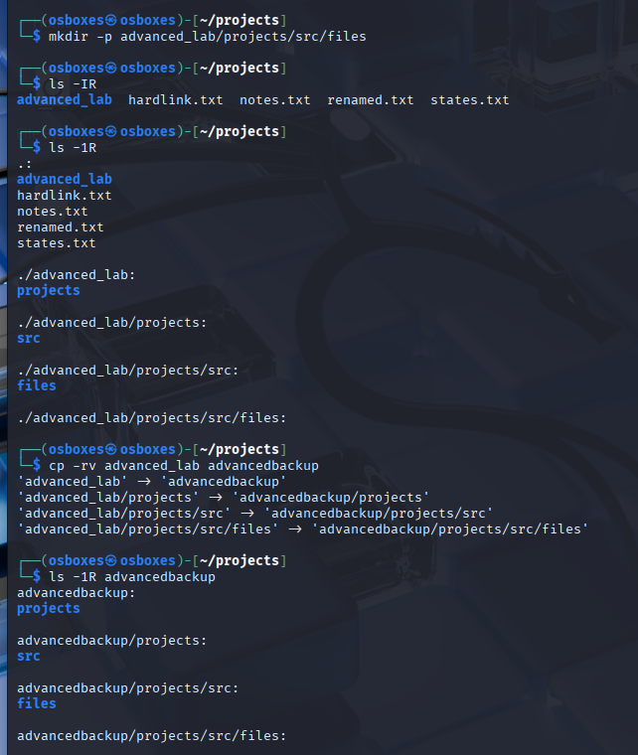

Q12. File Linking, Archiving, and Compression
Create a symbolic link (ln -s), and combine tar with gzip for archiving and inline extraction.
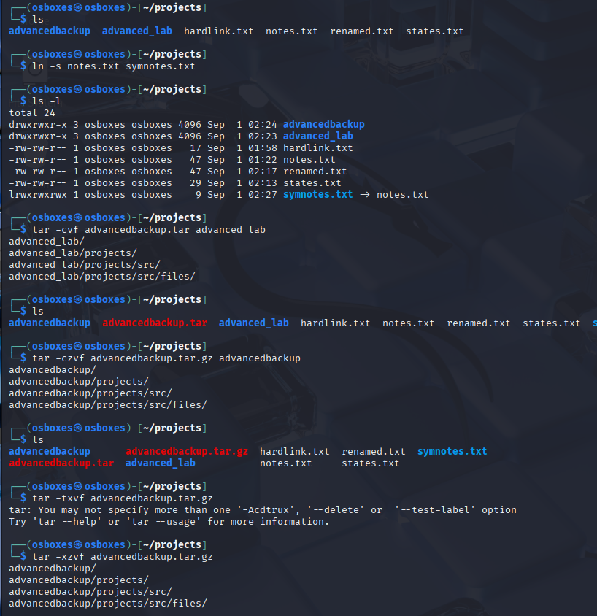
Q13. User, Job, and Process Management
Start a background job with sleep, list jobs, find processes with ps and grep, and use w to monitor users.
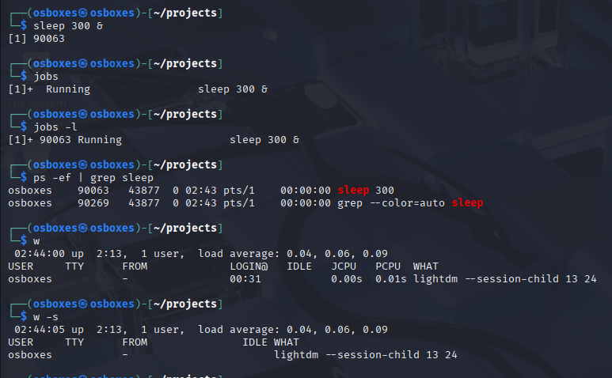
Q14. Data Filtering and Pattern Matching
Extract specific data from logs using grep, sort, uniq, wc, head, tail, and diff.
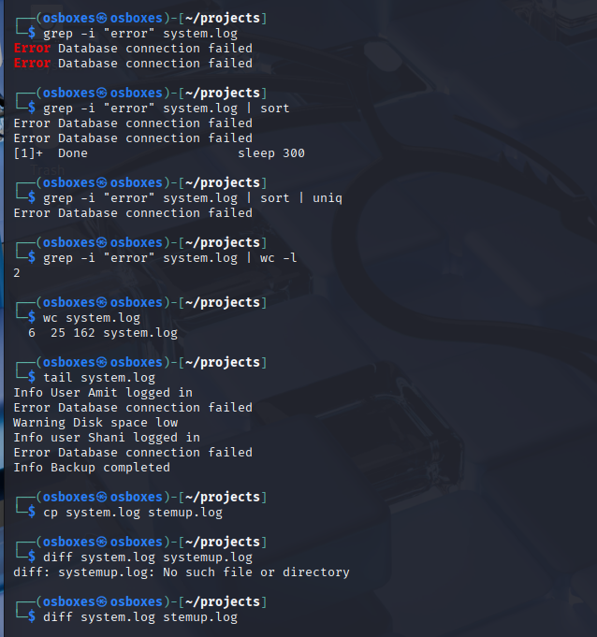
Q15. File Discovery and Metadata Analysis
Use locate, file, whatis, whereis, and man (specific sections) to locate and identify files.
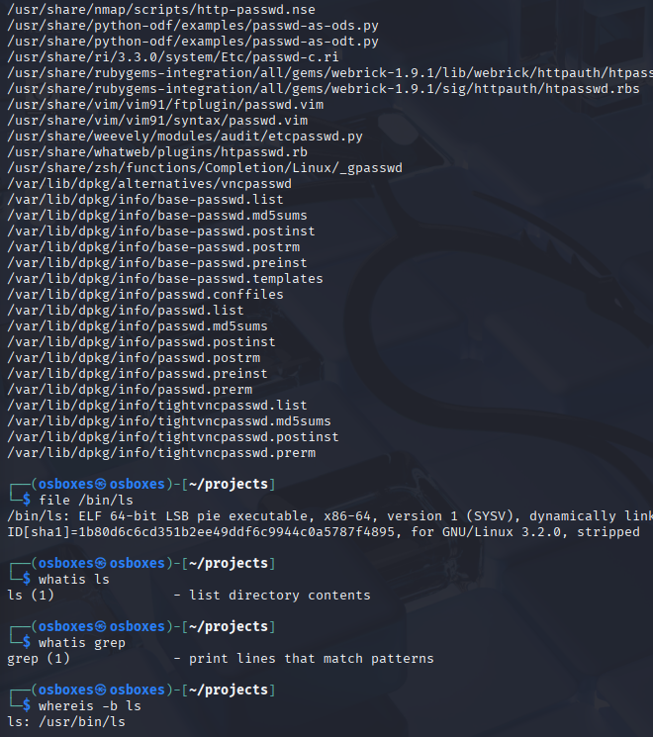
Q16. Working with Streams and Redirection
Manipulate multi-line strings with echo, tac, and filter archive streams with zcat and grep.
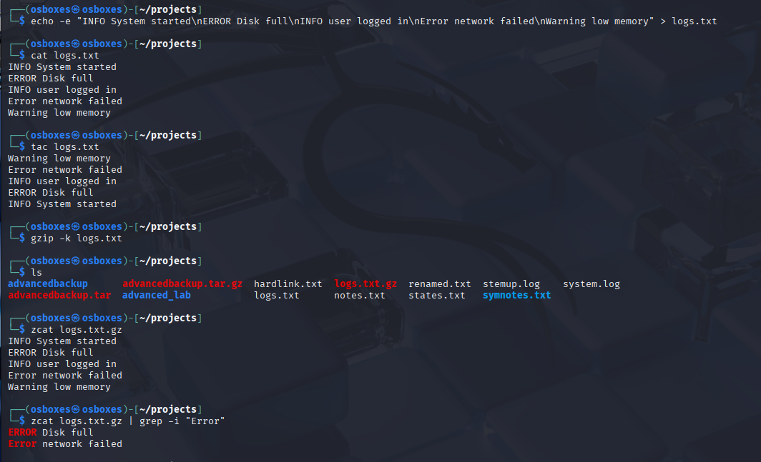
Q17. Printing and Reporting
Combine banner, date, cal, and bc outputs into a single report file using redirection, then print it.
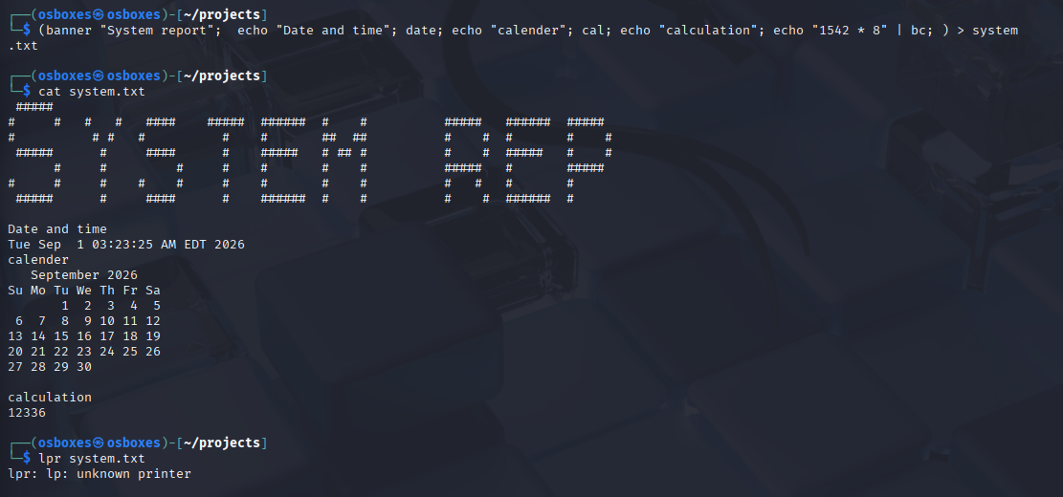
Q18. Custom Search Utilities with grep, find, and diff
Build small scripts/commands to search configuration files and compare backups.
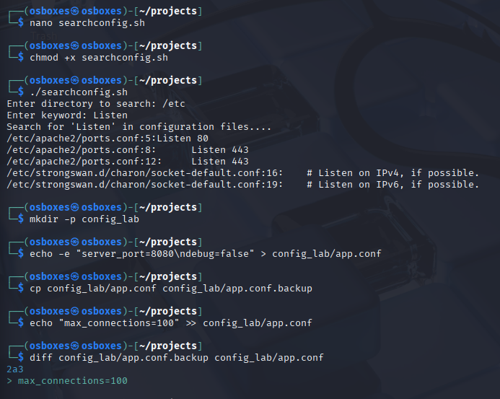
Q19. Process State and Job Control
Run background jobs, check job IDs, and use kill to terminate a background job.
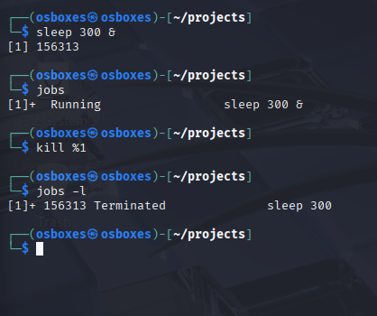
Q20. Automation Challenge - Daily Report Script
Write a script that outputs a banner, date, current user, active users, and top memory-consuming processes.
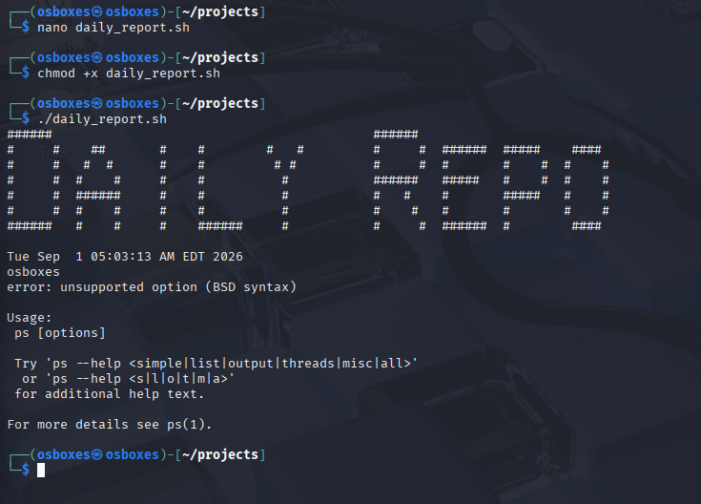

Part 3: Shell Scripting
Q21. Basic Shell Commands Script
Write a script combining echo, pwd, cd, ls, touch, cat, who, date, cal, wc.
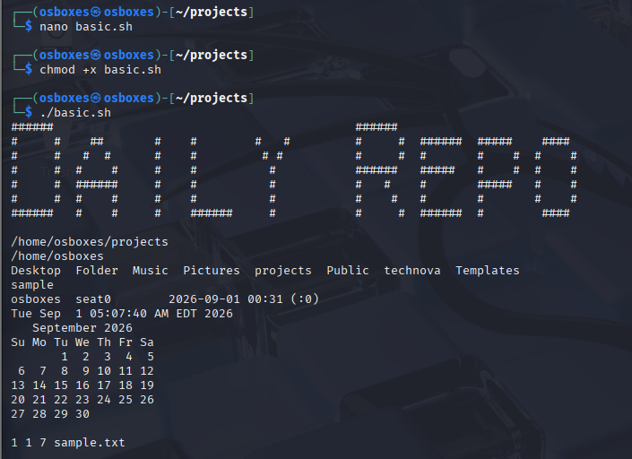
Q22. Writing Your First Shell Script
Write and execute a basic shell script that outputs a message, date, and whoami.
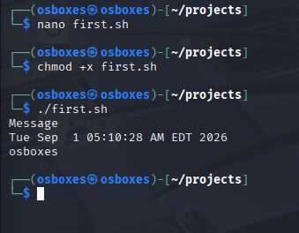
Q23. Conditional Statements in Scripts
Write scripts utilizing if, if-else, and if-elif-else constructs (e.g., positive/negative/zero or division by zero check).
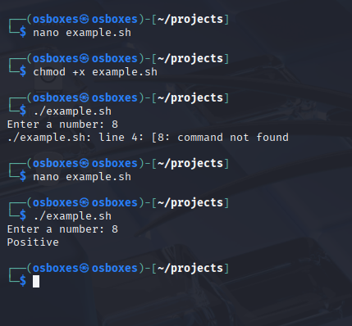
Q24. Loops in Shell Scripts
Implement examples of for, while, and until loops in a shell script.
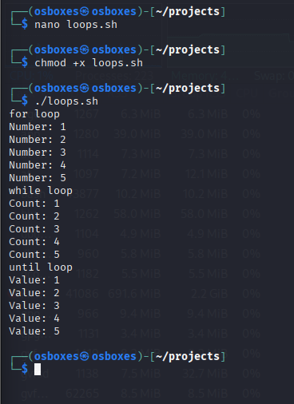
Q25. Script to Display System Info
Combine commands into a single script to report date, user, logged in users, and top memory processes.
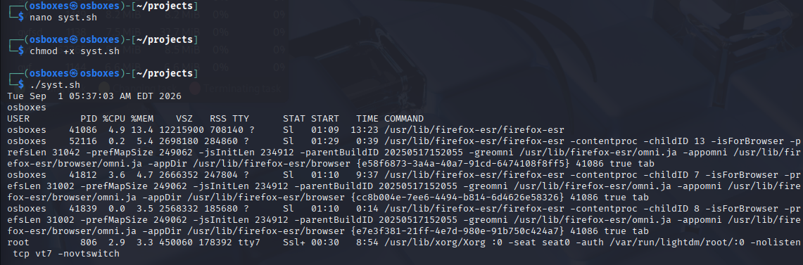
Q26. Log File Searcher Script
Write a script to search for a specific string in all .log files.
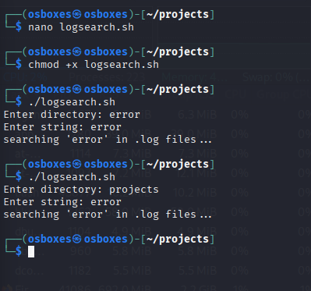
Q27. Even or Odd Checker
Write a script that checks if a user-provided number is even or odd.
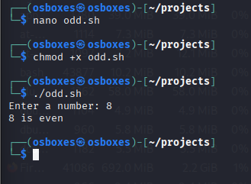
Q28. Age Calculator
Write a script that calculates age based on a birth year input.
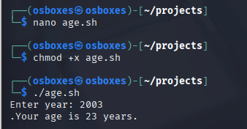
Q29. Countdown Timer
Write a script that acts as a countdown timer.
[ INSERT SCREENSHOT / ANSWER HERE ]
Q30. Advanced Parameter Handling
Write a script that handles script parameters ($#, $@, $0, $1, $2).
[ INSERT SCREENSHOT / ANSWER HERE ]
Q31. Case Statements in Scripts
Create a script with a case statement (e.g., start | stop | restart).
[ INSERT SCREENSHOT / ANSWER HERE ]
Q32. Using Arrays in Bash
Initialize an array of items (like fruits) and print specific elements and total counts.
[ INSERT SCREENSHOT / ANSWER HERE ]
Q33. Functions and Logging
Write a script that defines a logging function and appends timestamps and messages to a log file.
[ INSERT SCREENSHOT / ANSWER HERE ]
Q34. Loop with File Processing
Read a file (like /etc/passwd) line by line using a while loop.
[ INSERT SCREENSHOT / ANSWER HERE ]
Q35. Using `trap` and `exit`
Write a script that catches SIGINT (Ctrl+C) using trap and exits gracefully.
[ INSERT SCREENSHOT / ANSWER HERE ]
Q36. Background Jobs with Monitoring
Start a task in the background, capture its PID, and use wait.
[ INSERT SCREENSHOT / ANSWER HERE ]
Q37. Writing Cron Scripts
Write a script intended for cron, and provide the crontab entry required to run it every minute.
[ INSERT SCREENSHOT / ANSWER HERE ]
Q38. Advanced Grep with Script Integration
Extract failed login attempts from auth.log using grep and awk.
[ INSERT SCREENSHOT / ANSWER HERE ]
Q39. Automation Challenge – Backup Script
Write a script that creates a backup directory and compresses the Documents folder into a timestamped tar.gz archive.
[ INSERT SCREENSHOT / ANSWER HERE ]

Part 4: Text Editors (Vi/Vim & Nano)
Q40. Vi: Opening, Inserting, Saving, and Quitting
Open a file, enter insert mode, type text, save, and quit. Also test quitting without saving (:q!).
[ INSERT SCREENSHOT / ANSWER HERE ]
Q41. Vi: Basic Navigation
Use h, j, k, l, w, b, e, 0, $, gg, and G to navigate a large text file in Command Mode.
[ INSERT SCREENSHOT / ANSWER HERE ]
Q42. Vi: Deleting Text
Practice deleting characters (x), words (dw), lines (dd), to end of line (d$), and undo/redo (u, Ctrl+r).
[ INSERT SCREENSHOT / ANSWER HERE ]
Q43. Vi: Copying and Pasting
Use yank (yy) and put (p or P) to copy and paste text.
[ INSERT SCREENSHOT / ANSWER HERE ]
Q44. Vi: Searching and Replacing
Search forward (/) and backward (?), and perform inline and global search & replace (:s and :%s).
[ INSERT SCREENSHOT / ANSWER HERE ]
Q45. Vi: Advanced Commands
Enable line numbers (:set nu), jump to specific lines, and join lines (J).
[ INSERT SCREENSHOT / ANSWER HERE ]
Q46. Nano: Opening, Inserting, Saving, and Quitting
Open a file, type text, save using Ctrl+O, and quit using Ctrl+X.
[ INSERT SCREENSHOT / ANSWER HERE ]
Q47. Nano: Basic Navigation
Navigate using arrow keys, Ctrl+F, Ctrl+B, Ctrl+A, Ctrl+E, and Ctrl+_ to jump to a line.
[ INSERT SCREENSHOT / ANSWER HERE ]
Q48. Nano: Cutting, Copying, and Pasting
Cut a line (Ctrl+K), paste it (Ctrl+U), and use text selection (Alt+A).
[ INSERT SCREENSHOT / ANSWER HERE ]
Q49. Nano: Searching and Replacing
Search text using Ctrl+W and find/replace using Ctrl+\.
[ INSERT SCREENSHOT / ANSWER HERE ]
Q50. Nano: Miscellaneous Useful Commands
Display cursor position (Ctrl+C), insert another file (Ctrl+R), and justify text (Ctrl+J).
[ INSERT SCREENSHOT / ANSWER HERE ]

Part 5: Disk & File System Management
Q51. List Mounted File Systems
Run df -Th and identify different file systems (ext4, tmpfs, etc.).
[ INSERT SCREENSHOT / ANSWER HERE ]
Q52. Partition, Format, and Mount
Simulate adding a new disk. Use lsblk, fdisk (create partition), mkfs.ext4 (format), and mount it to /mnt/labdisk.
[ INSERT SCREENSHOT / ANSWER HERE ]

Part 6: Operating Systems Memory Management
Q53. Paging: Page Table Construction
Create a page table for a 32 KB logical space and 16 KB physical memory. Translate 3–5 logical addresses to physical addresses.
[ INSERT SCREENSHOT / ANSWER HERE ]
Q54. Segmentation: Segment Table Construction
Create a segment table with 3 segments. Translate 3 logical addresses and check for limit violations.
[ INSERT SCREENSHOT / ANSWER HERE ]
Q55. Demand Paging Simulation
Implement a script/program simulating FIFO and LRU page replacement. Test with reference string [1, 2, 3, 4, 1, 2, 5, 1, 2, 3, 4, 5] and compare page faults.
[ INSERT SCREENSHOT / ANSWER HERE ]
Q56. Theoretical: Trade-offs
What are the trade-offs between paging and segmentation?
[ INSERT SCREENSHOT / ANSWER HERE ]
Q57. Theoretical: Page Replacement
How does the page replacement strategy affect performance?
[ INSERT SCREENSHOT / ANSWER HERE ]
Q58. Theoretical: Page Faults
What happens during a page fault in a real OS?
[ INSERT SCREENSHOT / ANSWER HERE ]

